An investigation of self-reported health status among students at the University of South Wales on variation by age and sex.
Section 1: Context
Self-reported health, also commonly referred to as self-rated health, is a widely used measure of an individual's overall perception of their health (Hamplová et al., 2022). It is typically assessed through asking individuals to rate their general health using categories such as excellent, very good, good, fair, or poor. Despite its simplicity and subjective nature, self-reported health is recognized as a useful public health indicator because it captures multiple dimensions of health, such as physical, psychological, and social wellbeing. In the United Kingdom, measures of self-reported health are incorporated into major population surveys and health monitoring systems, including the Health Survey for England and the UK Census (Exton-Smith et al., 2026). This enables researchers and policymakers to assess differences in perceived health across demographic and socioeconomic groups.
An important strength of self-reported health is its association with more objective health outcomes (Hamplová et al., 2022). Research has demonstrated that individuals who report poorer general health are more likely to experience subsequent illness, functional limitations, healthcare utilization and mortality (Mutz & Lewis, 2022). Self-reported health can therefore provide information that may not be fully captured by diagnosed medical conditions alone. It is also relatively inexpensive and straightforward to collect, making it particularly suitable for large epidemiological studies and population surveys. Nevertheless, responses may be influenced by factors such as age, sex, socioeconomic circumstances, cultural expectations and an individual's interpretation of what constitutes good health. These factors should therefore be considered when examining differences between population groups.
University students represent an important population for studying self-reported health. Although students are often relatively young and may generally be expected to experience good physical health, university life can introduce a range of challenges that potentially affect wellbeing. Students may experience academic pressure, financial difficulties, changes in living arrangements, reduced physical activity, inadequate sleep and changes in dietary or health-related behaviors. Mental health is also an important concern within higher education. Recent UK evidence has highlighted substantial levels of psychological distress and demand for mental health support among university students (Remskar et al., 2022; Priestley et al., 2022). These experiences may influence how students perceive and report their overall health, even in the absence of diagnosed physical illness.
Student populations are also increasingly diverse, meaning that university students should not necessarily be treated as a single homogeneous group. Health status may vary according to demographic characteristics such as age and sex. Age is relevant because universities include both younger students entering higher education shortly after secondary education and mature students who may have different family responsibilities, employment commitments and existing health needs. More generally, population-level evidence indicates that health tends to vary with age, although the relationship within a university population may differ from patterns observed in the wider population.
Sex may also contribute to differences in self-reported health. Research frequently identifies differences between males and females in health behaviours, morbidity, mental wellbeing and patterns of healthcare use. Men and women may also differ in their perceptions of health and their willingness to report health concerns. Examining self-reported health according to sex may therefore reveal inequalities that would be obscured when considering the student population.
While extensive research has investigated student mental health and wellbeing, comparatively less attention has been given to students' broader perceptions of their general health, particularly within individual UK university populations. Understanding these patterns at the University of South Wales may provide useful evidence about the health of its student population and identify demographic groups reporting less favourable health.
The general objective of this study is to find whether self-reported health status among students at the University of South Wales vary according to age and sex.
Specifically, the study intends to find:
- Does self-reported general health (Q1, Q2) differ by age and by sex among USW students?
- Does self-reported physical health (Q3, Q5) differ by age and by sex?
- Does self-reported mental/emotional health (Q4, Q6) differ by age and by sex?
- Does healthcare utilisation (Q7) differ by age and by sex?
Section 2: Method and design
Research design
A quantitative, cross-sectional survey design was used to investigate self-reported health status among students at the University of South Wales. A cross-sectional design was appropriate because the study aimed to describe and compare self-reported health across demographic groups at a single point in time, rather than to measure change over time or establish causation (Sanchez et al., 2023). Cross-sectional surveys are widely used in public health research to examine the distribution of health indicators within a defined population and to identify associations between health outcomes and demographic characteristics such as age and sex.
Recruitment and sampling
Participants were students at the University of South Wales. A convenience, non-probability sampling approach was used. The questionnaire was made available online, and students accessed it by scanning a QR code that directed them to the survey.
Two inclusion criteria were applied:
- Participants had to be aged 18 years or over
- Be current students at the university.
A total of 57 students completed the questionnaire. Convenience sampling was appropriate given the time and resource constraints of the project. However, the reliance on self-selection is acknowledged as a limitation that may affect how well the sample represents the wider student population at the university, and this is considered further in the discussion.
Data collection
Data were collected using a structured, self-administered online questionnaire. The questionnaire comprised seven closed health-status questions and two demographic questions (age and sex). The health items addressed general health compared with one year ago (Q1), current general health (Q2), physical health (Q3), mental health (Q4), the extent to which physical health had interfered with normal social activities over the previous four weeks (Q5), the extent to which social, mental or emotional health had interfered with those activities (Q6), and the number of visits to a healthcare professional in the past twelve months (Q7). Items Q1 to Q6 used five-point ordinal response scales (for example, from "excellent" to "poor", or from "not at all" to "extremely"). Q7 used a six-category frequency scale that included a "prefer not to say" option. Responses were recorded for 57 participants (R1–R57).
Data organisation and analysis
Questionnaire responses were coded numerically and entered into IBM SPSS Statistics version 25 for analysis. Each ordinal response category (A–E) was assigned a corresponding numeric code, and value labels were applied so that the meaning of each category was retained during analysis. The demographic variables of age band and sex were coded as categorical variables. Missing and non-substantive responses, including the "NR" (no response) entry, "prefer not to say" responses to Q7, and any ambiguous or amended entries, were coded as missing data and excluded from the relevant analyses using pairwise exclusion.
Descriptive statistics (frequencies and percentages) were used to summarise participant demographics and the distribution of responses to each health item, presented using tables and bar charts. The full seven-band age structure was retained for descriptive purposes. However, because several of the older age bands contained very few participants, age was collapsed into three broader groups (18–22, 23–32, and 33 and above) for inferential testing, in order to achieve adequate group sizes and allow meaningful comparison.
Because the health items were measured on ordinal scales, non-parametric inferential tests were selected. Mann-Whitney U tests were used to examine whether self-reported health differed between the two sex groups, and Kruskal-Wallis tests were used to examine differences across the collapsed age groups, as these tests are appropriate for ordinal outcome data and do not assume a normal distribution. Chi-square tests of association, with Fisher's exact test applied where expected cell counts were low, were used for categorical comparisons and for collapsed binary outcomes. Where response categories for individual health items contained small numbers of participants, adjacent categories were collapsed for example, combining "excellent", "very good" and "good" into a single "good or better" category, and "fair" and "poor" into a "fair or poor" category — to allow meaningful comparison. A significance threshold of p < 0.05 was applied throughout. In line with the assessment requirements, SPSS output is presented as screenshots within the results section.

Ethical considerations
Ethical considerations were addressed throughout the study in accordance with the University of South Wales Ethics Policy for Research and Investigation-Based Work (2024). As the study involved a low-risk, questionnaire-based investigation with university students, it was reviewed through the University’s light-touch ethical review process. Participation was entirely voluntary, and participants were provided with information about the purpose of the study and what participation involved before informed consent was obtained. Participants were informed that they could decline to participate or withdraw without penalty. No directly identifying information, such as names or student identification numbers, was collected, helping to maintain anonymity. A “prefer not to say” option was provided where appropriate to allow participants to avoid answering questions they were uncomfortable with. Study data were stored securely, accessed only for research purposes, and handled in accordance with University data-protection requirements and applicable UK data-protection legislation, including the UK GDPR.
Data analysis
Data cleaning and coding
Prior to analysis, the questionnaire responses were cleaned and coded to prepare the dataset for entry into IBM SPSS Statistics version 25. Each of the 57 responses (R1–R57) was reviewed to identify missing, ambiguous or inconsistent entries. The categorical response options (A–E for the health items) were assigned numeric codes, and value labels were applied within SPSS so that the meaning of each category was preserved throughout the analysis. For the ordinal health items (Q1–Q6), responses were coded so that the numeric order reflected the underlying scale, with lower values representing more favourable health and higher values representing poorer health, ensuring consistency across items.
The demographic variables were coded separately. Sex was coded as a nominal categorical variable, and age was coded as an ordinal categorical variable using the age bands defined in the questionnaire. Question 7 (number of healthcare visits) was treated as an ordered categorical variable, with the "prefer not to say" response coded as missing data.
Several data-quality issues were identified and addressed during cleaning. One response to Q3 was recorded as "NR" (no response) and was coded as missing. Responses of "prefer not to say" to Q7 were similarly treated as missing and excluded from the relevant analyses. Where an entry was ambiguous or had been amended on the original response sheet, the entry was checked against the original record and, where it could not be resolved with confidence, coded as missing]. Missing data were handled using [pairwise / listwise exclusion, so that participants were included in each analysis for which they had valid responses. After cleaning, the dataset comprised [state the final usable n per variable if it differs, or "complete responses for the majority of items, with missing values noted where relevant".
All coding decisions were applied consistently across the dataset and documented to ensure transparency and reproducibility. The cleaned and coded dataset was then used for the descriptive and inferential analyses described below.
Data entry and management
Following coding, the questionnaire responses were entered into IBM SPSS Statistics version 25 for management and analysis. Data were organized so that each row represented an individual participant (R1–R57) and each column represented a single variable, producing a dataset of 57 cases across nine variables: the seven health items (Q1–Q7) and the two demographic variables (age and sex). This structure ensured that each participant's full set of responses was recorded on one line, consistent with the requirements for analysis in SPSS.
Each variable was defined within the SPSS Variable View before data entry. Variable names, labels and value labels were specified so that the numeric codes retained their meaning during analysis. The measurement level was set for each variable: the health items (Q1–Q6) and Q7 were defined as ordinal, age band was defined as ordinal, and sex was defined as nominal. Value labels were applied in line with the coding scheme (for example, for sex, 1 = male and 2 = female; and for the general health items, 1 = excellent through to 5 = poor), which allowed output tables and charts to display meaningful category labels rather than numeric codes.
Missing and non-substantive responses were managed consistently. Entries that could not be treated as valid responses including the "NR" (no response) entry recorded for Q3, and "prefer not to say" responses to Q7 were entered as missing values and defined as such in SPSS, so that they were automatically excluded from the relevant analyses. Where an entry on the original response sheet was ambiguous or had been amended, it was checked against the record and, where it could not be confirmed, coded as missing. Missing data were handled using [pairwise] exclusion, ensuring that each participant was retained in every analysis for which they provided a valid response, which was appropriate given the relatively small sample size.
Before analysis, the dataset was screened for accuracy. Frequency checks were run on each variable to confirm that all entered values fell within the expected range of valid codes and to identify any data-entry errors, which were corrected against the original response sheets. [Owing to small numbers within several of the seven age bands, age was subsequently collapsed into fewer categories for inferential testing, while the full band structure was retained for descriptive analysis.] The screened and finalised dataset was then used for the descriptive and inferential analyses reported below.
Results and findings
Descriptive statistics
Gender distribution
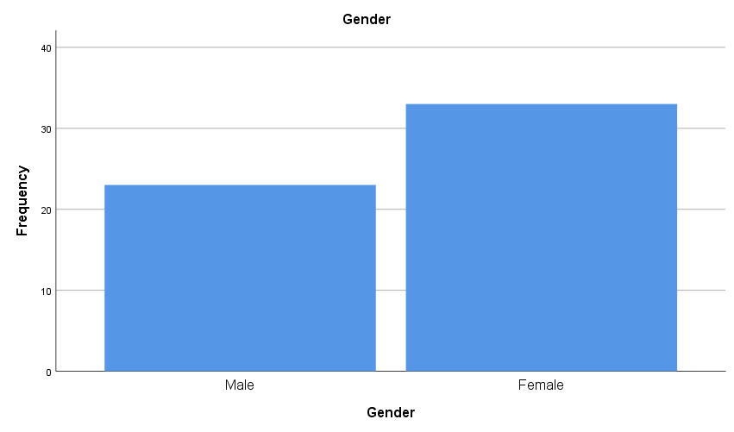
The sample contained more female than male students. Of the 56 participants who provided a valid response, 33 were female and 23 were male, meaning that women made up 58.9 percent of the sample and men 41.1 percent. One participant did not provide a valid gender response and was therefore excluded from analyses involving sex. The chart shows this imbalance clearly, with the female bar noticeably taller than the male bar. While a female majority is common in student health surveys, the uneven split should be kept in mind when interpreting differences between the two groups, since the smaller male group provides a narrower basis for comparison.
Age distribution
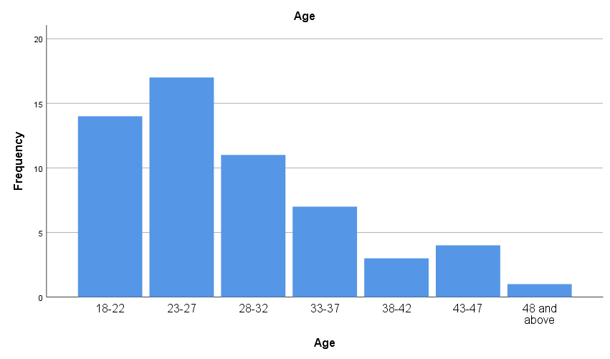
The sample was concentrated among younger students and thinned steadily across the older age bands. The largest groups were those aged 23 to 27, who accounted for 29.8 percent of participants, and those aged 18 to 22, who made up 24.6 percent. Together these two youngest bands represented more than half of the sample. A further 19.3 percent were aged 28 to 32, meaning that almost three quarters of students were 32 or younger. Beyond this point the numbers fell away sharply, with 12.3 percent aged 33 to 37, 5.3 percent aged 38 to 42, 7.0 percent aged 43 to 47, and only a single participant, representing 1.8 percent, aged 48 or above. The chart shows this decline as a series of falling bars from left to right. Because the older bands contained so few participants, the seven original bands were retained only for describing the sample, while age was collapsed into three broader groups for the comparative analyses, so that each group would be large enough to allow meaningful testing.
Health-item distributions
Health compared with a year ago
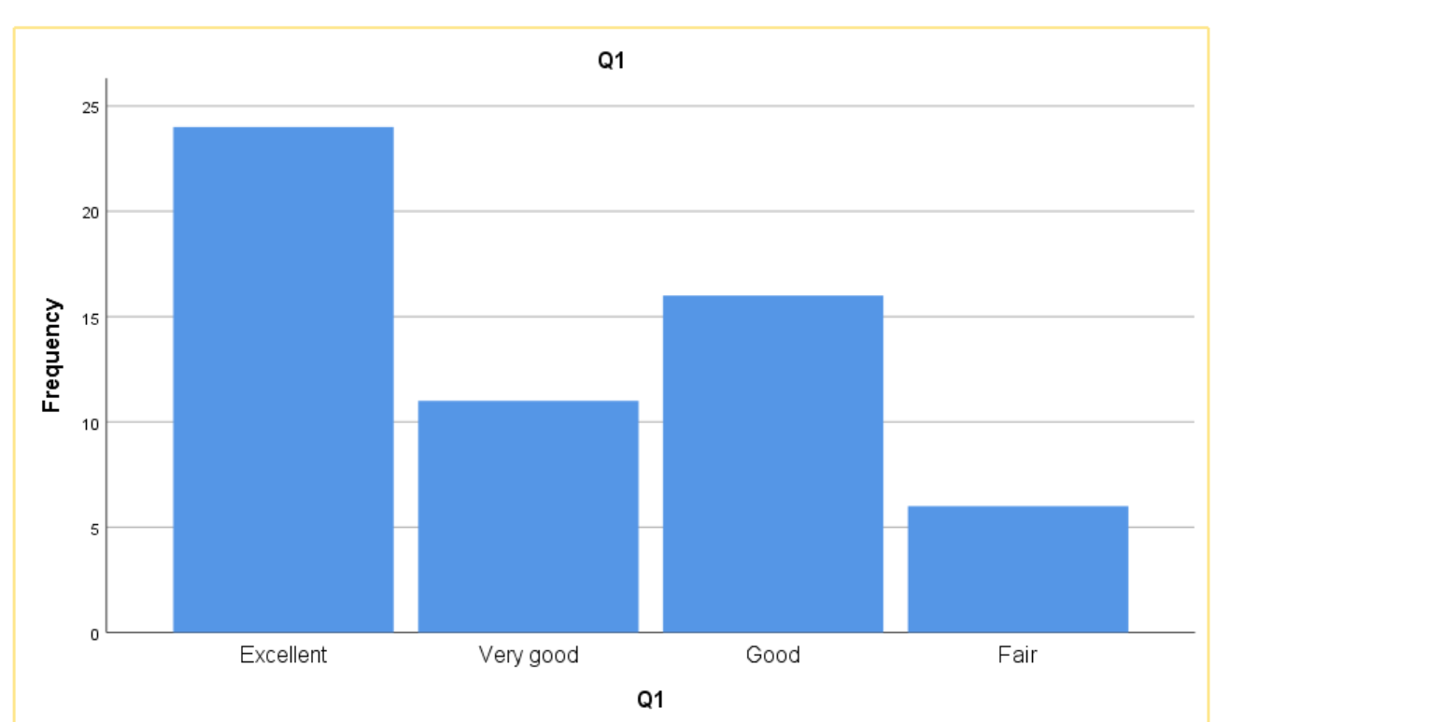
Most students felt their health had stayed the same or improved. Just over four in ten (42.1 percent) rated their health as much better than a year ago, a further 19.3 percent as somewhat better, and 28.1 percent as about the same. Only 10.5 percent felt their health had become worse. Overall the sample reported stable or improving health over the previous year.
General health
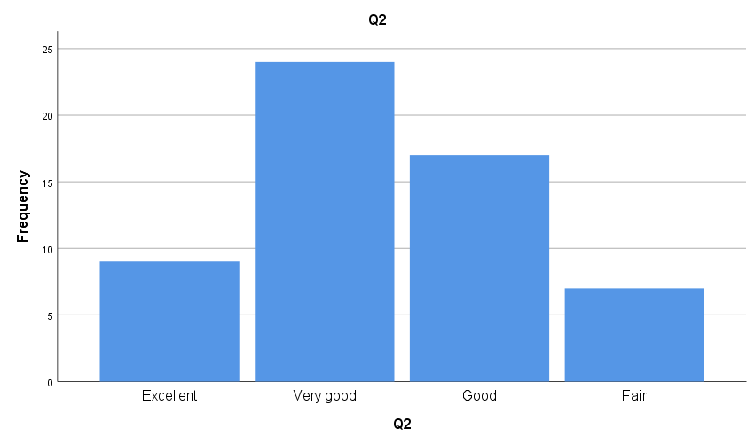
Ratings of general health were strongly positive. Around one in six students (15.8 percent) described their health as excellent, 42.1 percent as very good, and 29.8 percent as good. Taken together, 87.7 percent rated their general health as good or better, while only 12.3 percent selected fair and none selected poor. This indicates a generally healthy sample.
Physical health
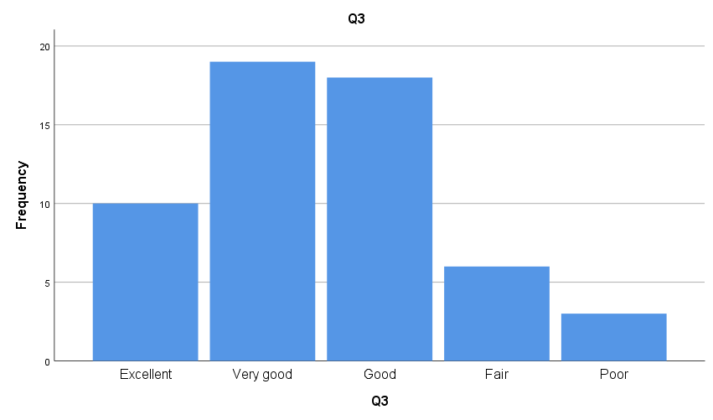
Physical health was also rated favourably. Almost 18 percent rated it excellent, 33.9 percent very good, and 32.1 percent good, meaning roughly 84 percent considered their physical health good or better. Only 10.7 percent chose fair and 5.4 percent poor. One response was missing for this item, giving a valid sample of 56.
Mental health
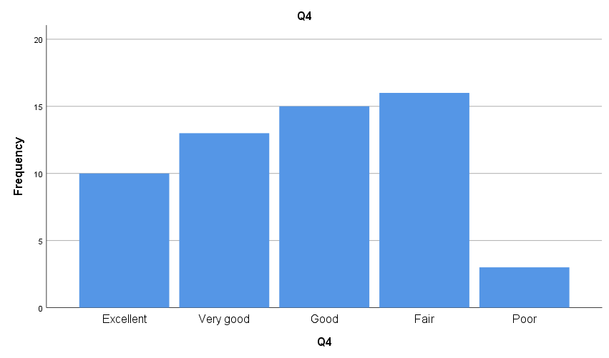
Mental health showed a markedly less positive pattern than physical health. Fewer students rated it at the top of the scale, with 17.5 percent excellent and 22.8 percent very good, while larger proportions clustered lower down, at good (26.3 percent) and fair (28.1 percent), and a further 5.3 percent rated it poor. In total, a third of students (33.4 percent) rated their mental health as fair or poor, compared with only around 16 percent for physical health. Mental health therefore emerged as the weakest dimension of self reported health in this sample.
Physical health interfering with social activities
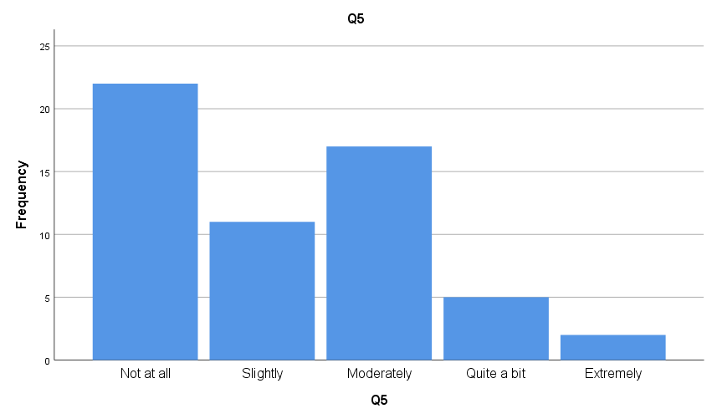
For most students, physical health placed little restriction on their social lives. Well over half reported either no interference at all (38.6 percent) or only slight interference (19.3 percent). A moderate effect was reported by 29.8 percent, and only 12.3 percent experienced substantial interference at the quite a bit or extremely levels. Physical health rarely disrupted normal social activity to a serious degree.
social, mental or emotional health interfering with social activities
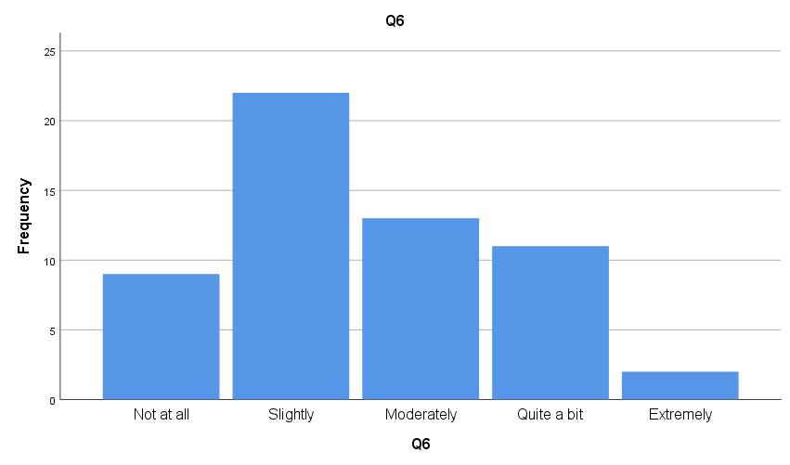
Emotional and mental health interfered with social life more often than physical health did. Only 15.8 percent reported no interference at all, compared with 38.6 percent for the equivalent physical item. Nearly half of the sample (45.6 percent) reported interference at the moderate level or above. This mirrors the pattern seen for mental health in Q4 and reinforces the picture of emotional wellbeing carrying a greater burden than physical health.
visits to a healthcare professional in the past twelve months
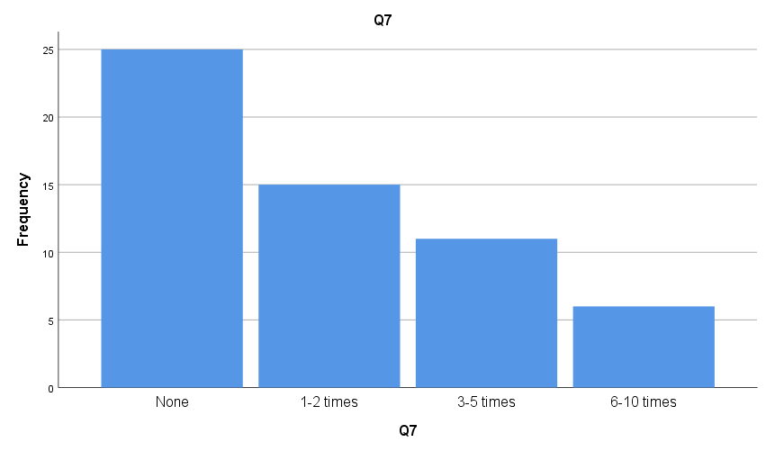
Healthcare use was generally low. Just under half of students (43.9 percent) had not visited a healthcare professional at all in the previous year, and 26.3 percent had visited only once or twice. Fewer reported three to five visits (19.3 percent) or six to ten visits (10.5 percent). Around seven in ten students therefore had two or fewer visits, which is consistent with a young and largely healthy sample.
Crosstabs
Gender
Health item | Male (%) | Female (%)
Q1 Health vs year ago – Excellent | 30.4 | 48.5
Q2 General health – Very good/Excellent | 65.2 | 51.6
Q3 Physical health – Very good/Excellent | 54.6 | 48.5
Q4 Mental health – Fair/Poor | 21.7 | 42.4
Q5 Physical interference – Not at all | 39.1 | 39.4
Q6 Emotional interference – Quite a bit/Extremely | 21.7 | 24.3
Q7 Healthcare visits – 3 or more | 8.7 | 42.4
The crosstabulation shows that self-reported health was broadly similar between men and women across most items. For general and physical health (Q1 to Q3), both sexes rated their health favourably, with only minor variations; women were slightly more likely to report their health as much better than a year ago, while men leaned towards very good on current general and physical health. The clearest descriptive difference appeared for mental health (Q4), where a larger proportion of women rated their mental health as fair or poor (42.4 percent) compared with men (21.7 percent), and only women rated it poor. A similar but milder pattern was seen for emotional interference with social activities (Q6), where women reported slightly more interference. The most pronounced difference was in healthcare use (Q7): over half of men (56.5 percent) had made no visits in the previous year and none had visited six to ten times, whereas women were spread across the higher visit categories, with 24.2 percent reporting three to five visits and 18.2 percent six to ten. Overall, the descriptive data suggest that men and women perceived their general and physical health similarly, but women reported somewhat poorer mental health and notably higher healthcare use, patterns that were then examined for statistical significance using Mann-Whitney U tests.

Age crosstabs

Item | Response | 18-22 (n=14) | 23-32 (n=28) | 33+ (n=15)
Q1 Health vs year ago | Excellent | 35.7 | 39.3 | 53.3
 | Very good | 35.7 | 14.3 | 13.3
 | Good | 28.6 | 28.6 | 26.7
 | Fair | 0.0 | 17.9 | 6.7
Q2 General health | Excellent | 21.4 | 7.1 | 26.7
 | Very good | 50.0 | 46.4 | 26.7
 | Good | 21.4 | 28.6 | 40.0
 | Fair | 7.1 | 17.9 | 6.7
Q4 Mental health | Excellent | 28.6 | 10.7 | 20.0
 | Very good | 7.1 | 21.4 | 40.0
 | Good | 21.4 | 32.1 | 20.0
 | Fair | 42.9 | 28.6 | 13.3
 | Poor | 0.0 | 7.1 | 6.7
Q5 Physical interference | Not at all | 35.7 | 32.1 | 53.3
 | Slightly | 28.6 | 17.9 | 13.3
 | Moderately | 14.3 | 35.7 | 33.3
 | Quite a bit | 21.4 | 7.1 | 0.0
 | Extremely | 0.0 | 7.1 | 0.0
Q6 Emotional interference | Not at all | 28.6 | 7.1 | 20.0
 | Slightly | 42.9 | 32.1 | 46.7
 | Moderately | 7.1 | 28.6 | 26.7
 | Quite a bit | 14.3 | 28.6 | 6.7
 | Extremely | 7.1 | 3.6 | 0.0
Q7 Healthcare visits | None | 50.0 | 50.0 | 26.7
 | 1-2 times | 21.4 | 25.0 | 33.3
 | 3-5 times | 28.6 | 14.3 | 20.0
 | 6-10 times | 0.0 | 10.7

The table shows several patterns across the three age groups, though all should be read as descriptive only until confirmed by testing.
For general health change (Q1), positive ratings increased with age. Just over a third of the youngest group (35.7 percent) rated their health as much better than a year ago, rising to 53.3 percent in the oldest group. Current general health (Q2) showed no clear age trend, with all three groups rating their health favourably overall.
Mental health (Q4) showed the clearest age pattern, and it ran counter to what might be expected. The youngest students reported the least favourable mental health, with 42.9 percent rating it fair, the highest of any group and with none rating it very good. Mental health ratings improved with age, so that the oldest group was most concentrated in the very good category (40.0 percent) and had the lowest proportion rating it fair (13.3 percent). Younger students therefore appeared to report poorer mental health than older students.
The two social interference items were more mixed. Physical health interfered with social life slightly less as age increased, with the oldest group most likely to report no interference at all (53.3 percent) and least likely to report substantial disruption. Emotional interference (Q6) did not follow a clear linear trend, with the middle group (23 to 32) reporting the most interference at the higher levels.
Healthcare use (Q7) increased with age. Half of the youngest and middle groups had made no visits in the previous year, compared with only 26.7 percent of the oldest group, and frequent use in the six to ten visits category rose from none in the youngest group to 20.0 percent in the oldest.

Inferential tests
Mann-Whitney by sex
Test Statisticsª
 | Q1 | Q2 | Q3 | Q4 | Q5 | Q6 | Q7
Mann-Whitney U | 343.500 | 347.500 | 359.000 | 319.500 | 359.000 | 356.000 | 248.000
Wilcoxon W | 904.500 | 623.500 | 920.000 | 595.500 | 920.000 | 632.000 | 524.000
Z | -.632 | -.565 | -.072 | -1.029 | -.358 | -.407 | -2.328
Asymp. Sig. (2-tailed) | .527 | .572 | .943 | .303 | .720 | .684 | .020
Exact Sig. (2-tailed) | .533 | .578 | .950 | .307 | .725 | .691 | .019
Exact Sig. (1-tailed) | .268 | .289 | .478 | .154 | .366 | .343 | .008
Point Probability | .004 | .010 | .014 | .002 | .009 | .004 | .000
a. Grouping Variable: Gender
Only one significant sex difference emerged. Women reported significantly more visits to a healthcare professional than men (Mann-Whitney U = 248.0, Z = -2.328, p = 0.020), with a higher mean rank for women (32.48) than men (22.78), indicating greater healthcare utilisation among female students. No statistically significant differences were found between men and women for general health (Q1, p = 0.527; Q2, p = 0.572), physical health (Q3, p = 0.943; Q5, p = 0.720), or mental and emotional health (Q4, p = 0.303; Q6, p = 0.684). Although women rated their mental health less favourably than men descriptively, this difference did not reach statistical significance. Overall, male and female students perceived their general, physical and mental health similarly, with the only significant sex difference being higher healthcare use among women.
Age and Kruskal-Wallis
Item | 18–22 | 23–32 | 33+ | Highest (least favourable)
Q1 Health vs year ago | 27.61 | 31.36 | 25.90 | 23–32
Q2 General health | 24.68 | 31.98 | 27.47 | 23–32
Q3 Physical health | 25.21 | 32.52 | 24.33 | 23–32
Q4 Mental health | 29.36 | 31.48 | 24.03 | 23–32
Q5 Physical interference | 29.46 | 31.52 | 23.87 | 23–32
Q6 Emotional interference | 24.11 | 34.11 | 24.03 | 23–32
Q7 Healthcare visits | 26.71 | 27.16 | 34.57 | 33+

Across the seven items, the middle age group (23 to 32) consistently recorded the highest mean ranks, meaning they tended to rate their health least favourably on general health, physical health, mental health and both interference items. The youngest (18 to 22) and oldest (33 and above) groups generally reported more favourable health, with the oldest group recording the lowest ranks on physical health, mental health and physical interference. The only exception was healthcare use (Q7), where the oldest group had the highest rank, indicating they visited healthcare professionals most often. Overall, the descriptive picture suggests that students aged 23 to 32 reported the poorest self-rated health, while healthcare use rose with age. However, these mean ranks indicate direction only; whether any of these age differences are statistically significant is determined by the Kruskal-Wallis test statistics, reported next.
Test Statistics^{a,b}
 | Q1 | Q2 | Q3 | Q4 | Q5 | Q6 | Q7
Kruskal-Wallis H | 1.325 | 2.217 | 3.460 | 2.096 | 2.301 | 5.665 | 2.582
df | 2 | 2 | 2 | 2 | 2 | 2 | 2
Asymp. Sig. | .515 | .330 | .177 | .351 | .316 | .059 | .275
a. Kruskal Wallis Test
b. Grouping Variable: Age group collapsed

There were no significant differences in self-reported health were found across the three age groups for any of the seven items, with all p-values above the 0.05 threshold (Q1 p = .515; Q2 p = .330; Q3 p = .177; Q4 p = .351; Q5 p = .316; Q6 p = .059; Q7 p = .275). Although the descriptive data suggested that students aged 23 to 32 tended to rate their health least favourably and that healthcare use increased with age, these patterns were not strong enough to reach statistical significance in this sample. The clearest difference was for emotional health interfering with social activities (Q6), which approached but did not reach significance (Kruskal-Wallis H = 5.665, p = .059), with the 23 to 32 group tending to report the most interference.
Discussion
This study investigated self-reported health among students at the University of South Wales and whether it varied according to age and sex. Overall, students reported favourable general and physical health, while mental and emotional health appeared comparatively less favourable. There was little evidence of differences according to age or sex, with the exception of healthcare utilisation, which was significantly higher among female students.
General, physical and mental health
Most participants rated their general and physical health positively, with 87.7% reporting good or better general health and approximately 84% reporting good or better physical health. This is perhaps unsurprising given that the sample was predominantly young. Nevertheless, these findings are important because self-rated health can capture dimensions of health that may not be identified through diagnosed conditions alone. Hamplová et al. (2022) found that self-rated health was influenced by physical, psychological and socioeconomic factors, supporting its usefulness as a broad measure of health.
Mental health presented a less positive picture. Approximately one-third of participants rated their mental health as fair or poor, while emotional and mental health interfered with social activities more frequently than physical health. This broadly supports Remskar et al. (2022), who identified student mental health and wellbeing as an important concern within higher education. Similarly, Priestley et al. (2022) found that student distress can be influenced by academic pressures, competition, financial concerns and wider university conditions.
However, the present study did not measure these potential causes. It would therefore be inappropriate to conclude that university pressures directly caused the poorer mental-health ratings. The findings instead show that mental and emotional health were comparatively weaker dimensions within this sample and warrant further investigation.
Differences by sex
Descriptively, females reported poorer mental health than males, with 42.4% of females rating their mental health as fair or poor compared with 21.7% of males. However, this difference was not statistically significant (p = .303). This illustrates the importance of distinguishing between an observed percentage difference and statistical evidence of a group difference.
The only statistically significant sex difference concerned healthcare utilisation (p = .020), with females reporting more healthcare visits than males. This does not necessarily mean that females were less healthy. Higher utilisation could reflect differences in healthcare needs, preventive care or willingness to seek professional support. These factors were not measured, so the explanation for the difference cannot be established.
The lack of significant sex differences across most health outcomes should also be interpreted cautiously because only 23 males and 33 females were included in the sex comparisons. The relatively small and unequal groups may have reduced the ability to detect genuine differences.
Differences by age
No statistically significant differences were found between the three age groups for any health outcome. This contrasts to some extent with Hamplová et al. (2022), who identified age as an important factor in self-rated health. However, their research involved a much larger general-population sample, whereas the present study involved a small university sample concentrated among younger adults. Direct comparison should therefore be made cautiously.
The 23–32 group nevertheless tended to have less favourable mean ranks across several health measures. Emotional interference (Q6) came closest to statistical significance (p = .059), but remained above the study's p < .05 threshold. This should therefore be treated as a possible pattern for future investigation rather than evidence of an age difference.
Strengths and limitations
A strength of the study was its consideration of several dimensions of health, including general, physical, mental and emotional health and healthcare utilisation. This reflects the multidimensional nature of self-rated health described by Hamplová et al. (2022). The use of non-parametric tests was also appropriate for the ordinal questionnaire data.
However, several limitations should be recognised. The sample was small (n = 57) and recruited through convenience sampling, limiting the extent to which the findings can be generalised to all USW students. The age and sex groups were also unevenly distributed. In addition, all measures were self-reported and may have been affected by differences in individual perceptions of health.
The cross-sectional design is another limitation because it identifies patterns at one point in time but cannot establish cause and effect. Although previous research such as Priestley et al. (2022) identifies academic and wider contextual pressures that can affect student wellbeing, the present study cannot determine whether these factors explain the mental-health findings.
Conclusion of the discussion
The findings broadly support previous research highlighting mental and emotional wellbeing as important issues within university populations. General and physical health were largely favourable, but mental health was comparatively poorer. Age and sex were not significantly associated with most health outcomes, although females reported significantly greater healthcare utilisation. Given the small, non-random sample, these findings should be interpreted cautiously. Further research using a larger and more representative sample would help determine whether the patterns identified are also present across the wider USW student population.

References
Hamplová, D., Klusáček, J., & Mráček, T. (2022). Assessment of self-rated health: The relative importance of physiological, mental, and socioeconomic factors. PLoS One, 17(4), e0267115. https://doi.org/10.1371/journal.pone.0267115
Exton-Smith, H., Sousi, S., Alharbi, A., El-Osta, A., Greenfield, G., Hayhoe, B., ... & Luísa Neves, A. (2026). Factors Associated With Digital Health Literacy in the United Kingdom: Cross-Sectional Online Survey. Journal of Medical Internet Research, 28, e89136. https://doi.org/10.2196/89136
Mutz, J. and Lewis, C.M. (2022) ‘Cross-classification between self-rated health and health status: longitudinal analyses of all-cause mortality and leading causes of death in the UK’, Scientific Reports, 12, 459. https://doi.org/10.1038/s41598-021-04016-x
Remskar, M., Atkinson, M.J., Marks, E. and Ainsworth, B. (2022) Understanding university student priorities for mental health and well-being support: A mixed-methods exploration using the person-based approach’, Stress and Health. https://doi.org/10.1002/smi.3133
Priestley, M., Broglia, E., Hughes, G. and Spanner, L. (2022) ‘Student mental health in higher education: the contextual influence of “cuts, competition & comparison”’, British Journal of Educational Psychology, 92(2), e12461. https://doi.org/10.1111/bjep.12461
Sanchez, T.R., Inostroza-Nieves, Y., Hemal, K. and Chen, W. (2023) ‘Cross-sectional study’, in Handbook for Designing and Conducting Clinical and Translational Surgery. Elsevier, pp. 219–222. https://doi.org/10.1016/B978-0-323-90300-4.00030-6

